Group 2

**Group Member’s Names:**

1. Ann-Gayle Briones
2. Lizette Ann Bueno
3. Mark Gerlan Cabe
4. Kyle Cedrick Cancio

**Yr. and Sec.:**

2CSA

**Professor/Instructor:**

ENGR. LYZA MARIE G. LUCHICO

**About the files:**

* The folder named "**SOURCE CODES**" found inside the "**GROUP 2 - SPECIFIC HEATS OF SOLIDS**" folder contains the source codes of the executable files. This will serve as a proof that Group 2 alone made the program.
* To open any of the *.java files included in the "**SOURCE CODES**" folder, an IDE like *NetBeans* or *CodeBlocks* is needed, if not available, any text editor like *NotePad++* or the built-in Notepad text editor included in your Windows OS may be used.
* The ”**GROUP 2 - PROGRAM DOCUMENTATION.docx**" shows the documentation of the features of the program.

**About the executable files:**

* The file executable JAR File **Group_2_Experiment4_and_WordProblems.jar** includes different classes of the program. It includes the *Experiment 4 solver*, two word problems, and a definition of terms and references classes.

1. 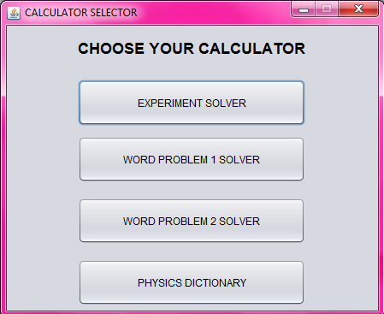Opening the **Group_2_Experiment4_and_WordProblems.jar** will open a prompt window with four choices on which function to use.
2. 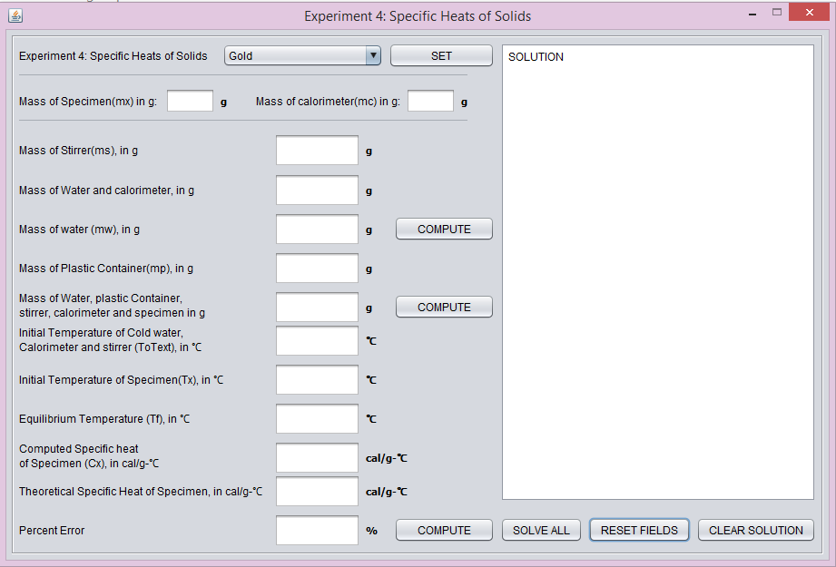If the user wisher to start calculating for the experiment, clicking the experiment solver button and will open the Experiment 4: Specific Heats of Solids window.
3. On the upper part of the window, a dropdown list allows the user to choose a preset specimen with its theoretical specific heat to be used in the program.

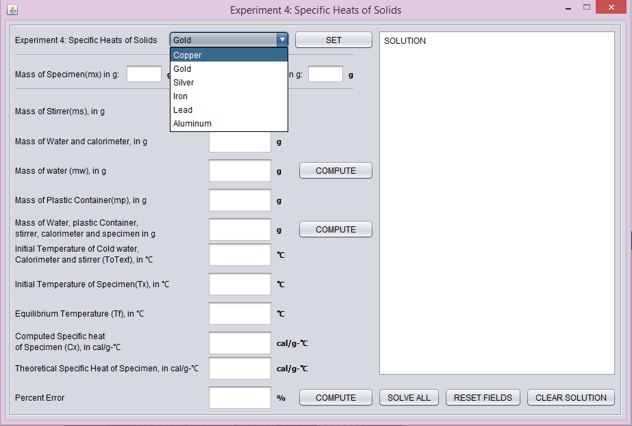

1. 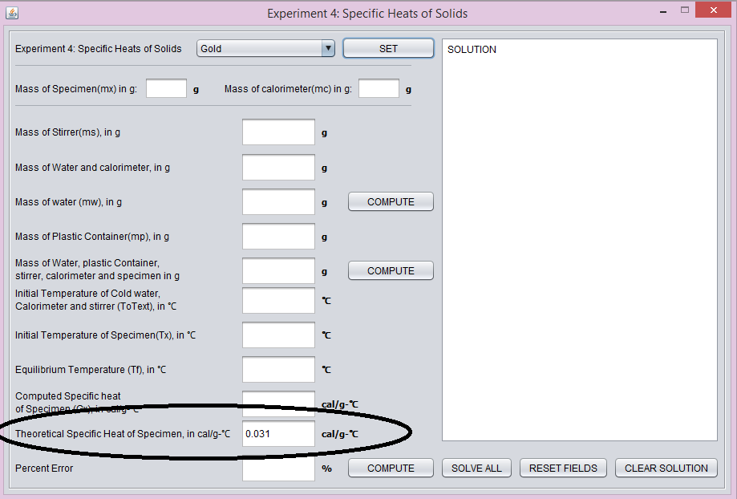Clicking the [SET] button will automatically input the preset value of the chosen specimen in the "**Theoretical Specific Heat of Specimen**” field.
2. 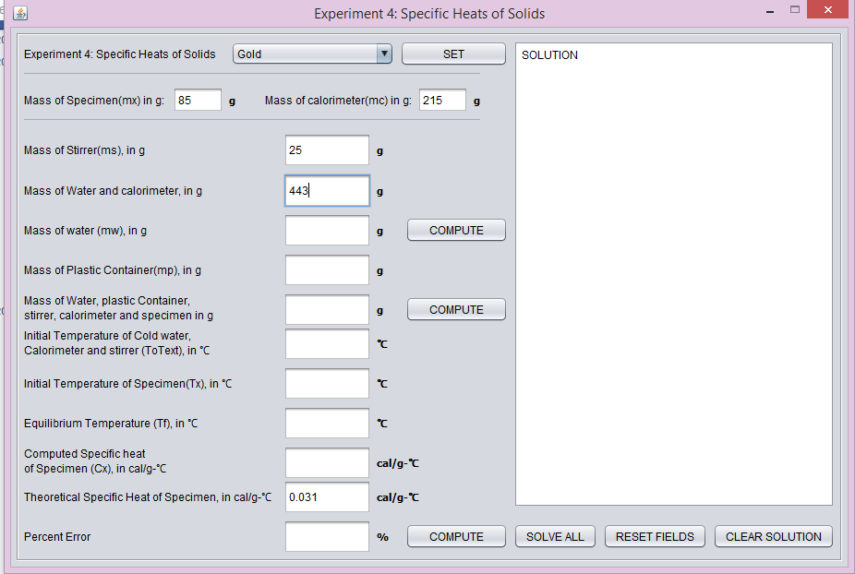To start the computation, the user must input values in the **mc** and **Mass of Water and calorimeter** fields, as part of the program, the user may or may not click the [COMPUTE] button for the program will automatically use a correct computed value in the rest of the program even without clicking the [COMPUTE] button beside the "**Mass of water**" field
3. 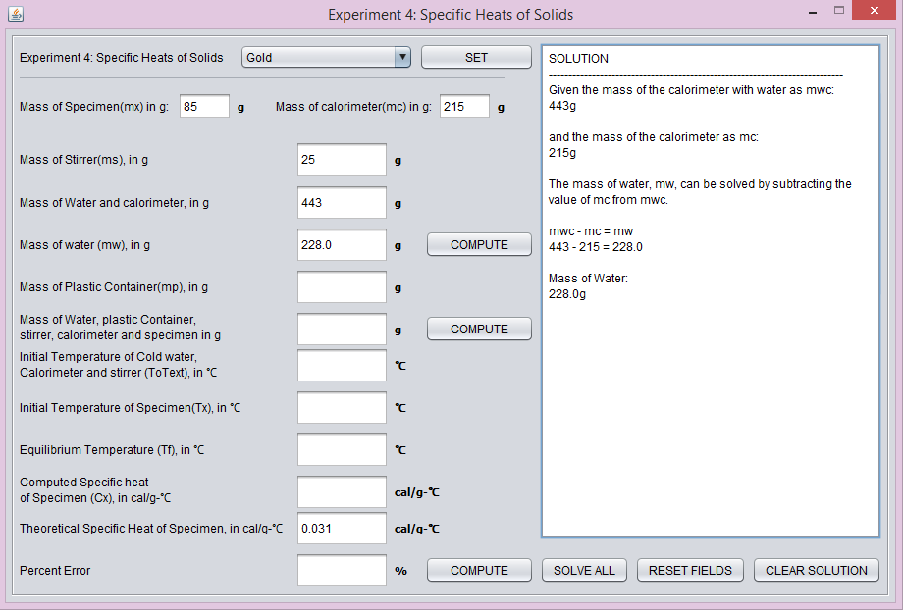After the user inputs the values for the mc and the combined mass of water and calorimeter, clicking on the [COMPUTE] button will automatically solve for the unknown mass of water and it will be shown on the **mw** field. The program will also show the solution in solving for the mass of water in the SOLUTION field on the right
4. 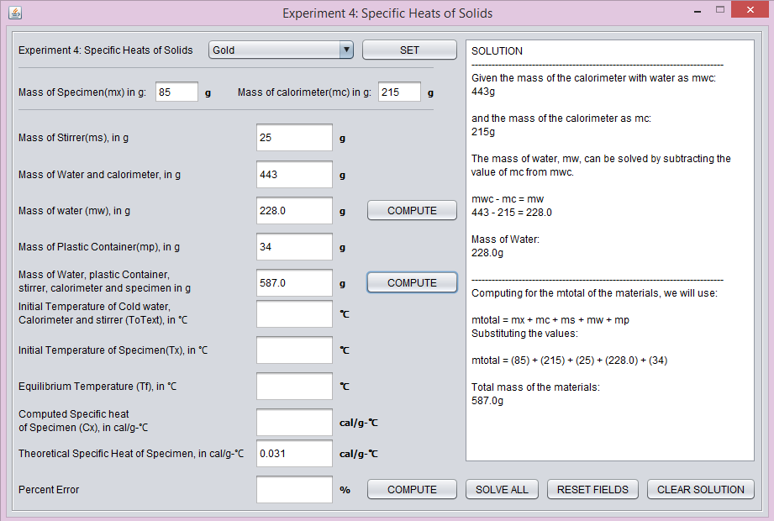The user may now input values for the mass of the specimen **mx** and mass of the plastic container **mp** fields. Clicking on the [COMPUTE] button beside the "**mass of water, plastic container, stirrer, calorimeter, and specimen**" field will compute for the total mass of the materials and will show the solution in the solution field.

1. After the program computes for the total mass of the materials, the user may now input values for the initial temperature of water and of the specimen, and for the equilibrium temperature of the materials. Clicking on the [COMPUTE] button beside the **Percent Error** fieldwill compute for the **Computed Specific Heat of Specimen**. If the user sets the value of the theoretical specific heat, the program will then compute for the percent error / difference of the data. Computation will also be shown on the solution field.

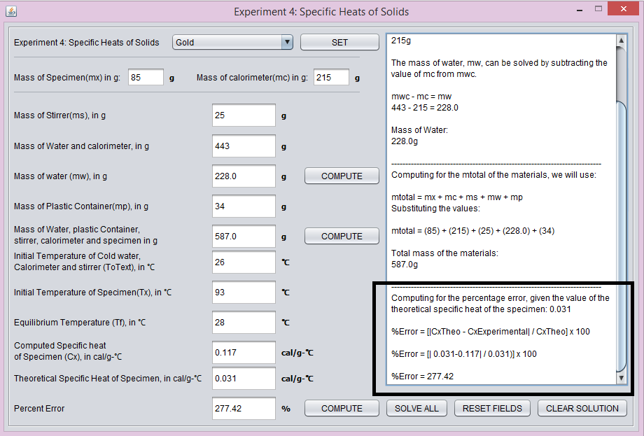

1. 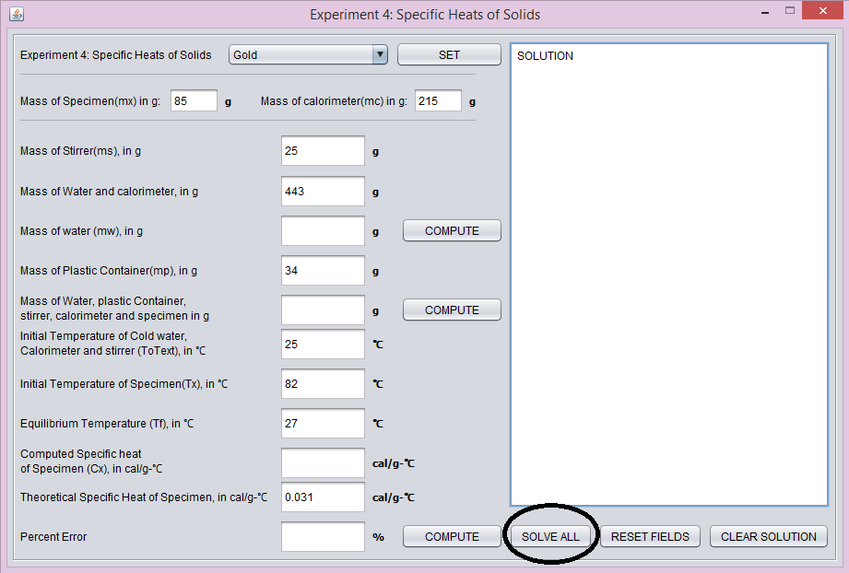If the user wishes not to compute for the unknowns, one-by-one, the user may click the [SOLVE ALL] button for the program to automatically solve unknowns and show the corresponding solutions on the solution field.
2. 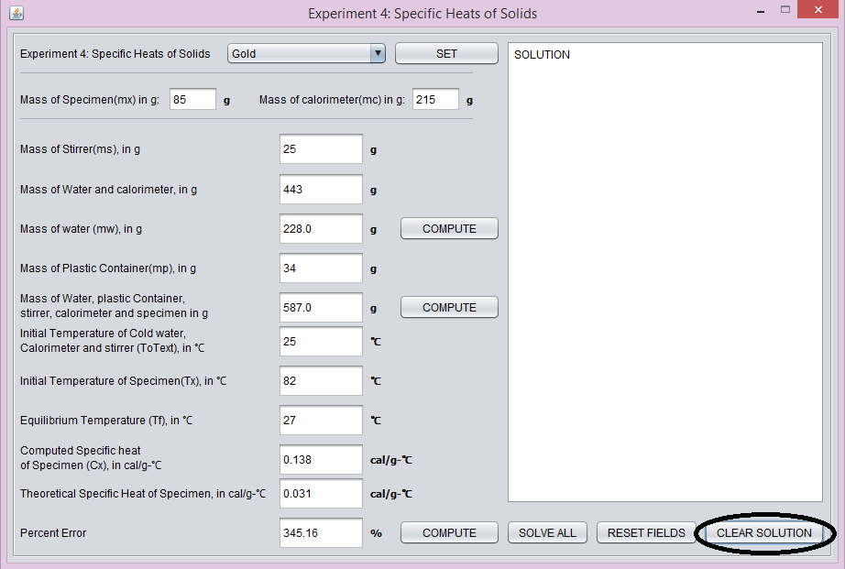The [CLEAR SOLUTION] buttons clears the texts in the solution field on the right of the program window.
3. 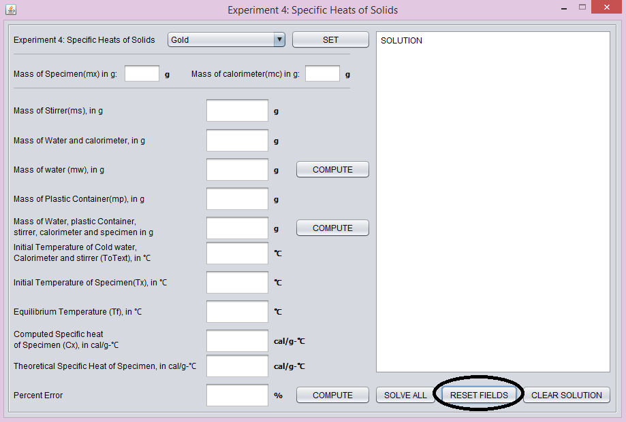The [RESET FIELDS] button will clear out all the data fields.  
   12. Closing the Experiment 4 window will return the program to the CALCULATOR SELECTOR window



In the CALCULATOR SELECTOR, there are two buttons for two word problems.

13. Clicking the [WORD PROBLEM 1] button will show the window for the first word   
problem.

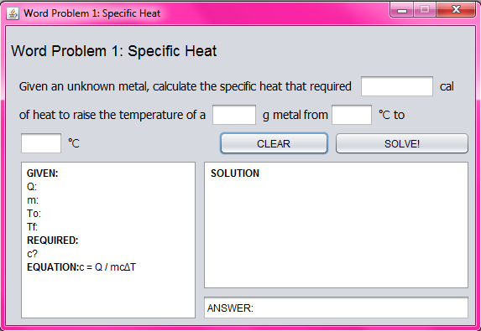It will display the word problem under Specific Heat. The calculator for the first word problem is displayed in **GRESA** format. The given values, the required, and the equation to be used is shown on the first text area on the left. The solution of the word problem on the top right text area, and the answer below the solution area.

14. The user may input the values in the blank textfields of the word problem. Clicking on the [SOLVE!] button will show the given values, the solution, and the answer for the problem.

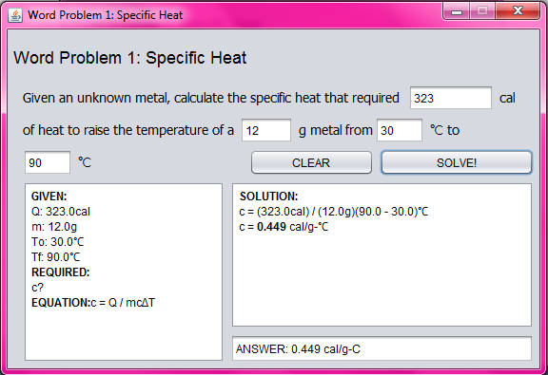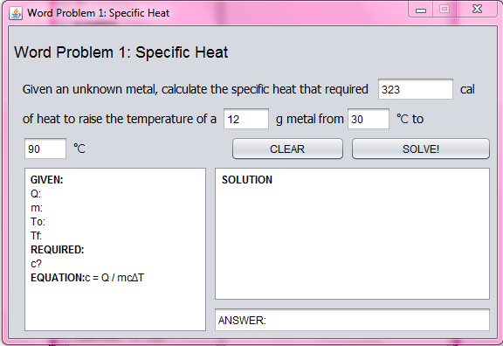

15. If any chance that, the user mistyped or inserted an invalid value (e.g. a non-numeric character) an error window will appear.

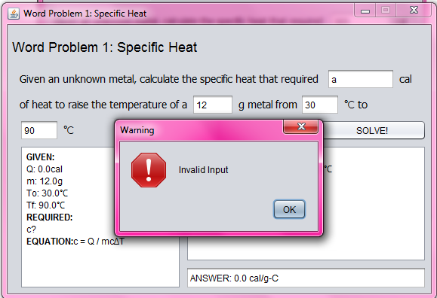

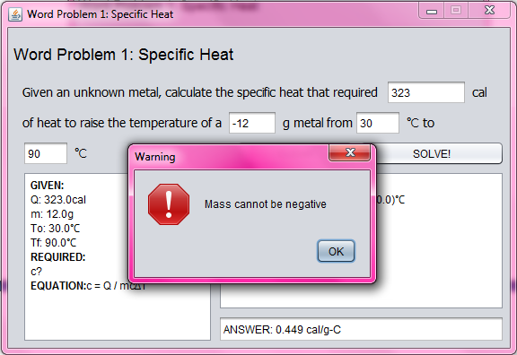16. If the user inputs a negative mass, an error window will appear informing the user that the mass cannot be of a negative value.

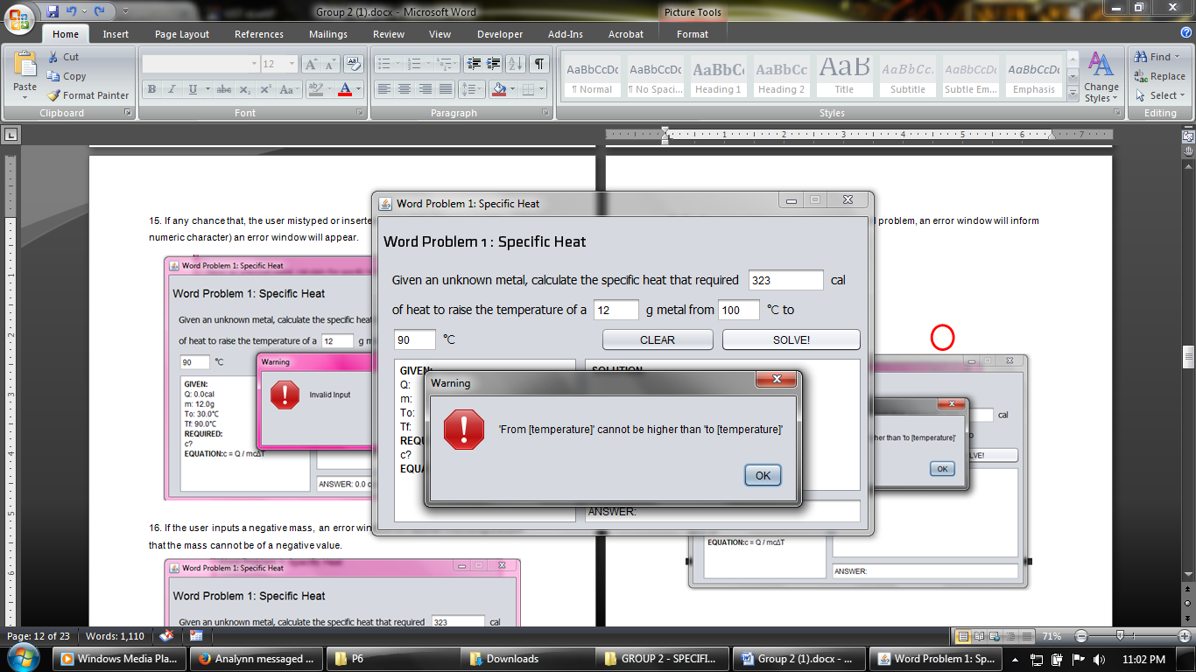17. For the computation is restricted to the wordings of the word problem, an error window will inform the user that the "FROM [temperature] cannot be higher than the TO [temperature]"

18. Clicking on the [CLEAR] button will clear out all the fields and the GRESA text areas

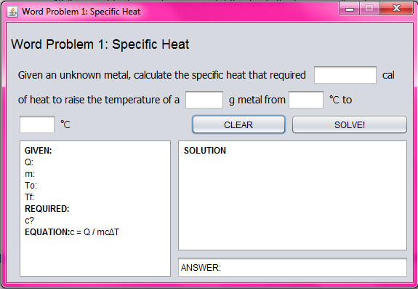

19. Closing the window will return the program to the selector menu.



20. Clicking on the [WORD PROBLEM 2] button will open the Word Problem 2 window.

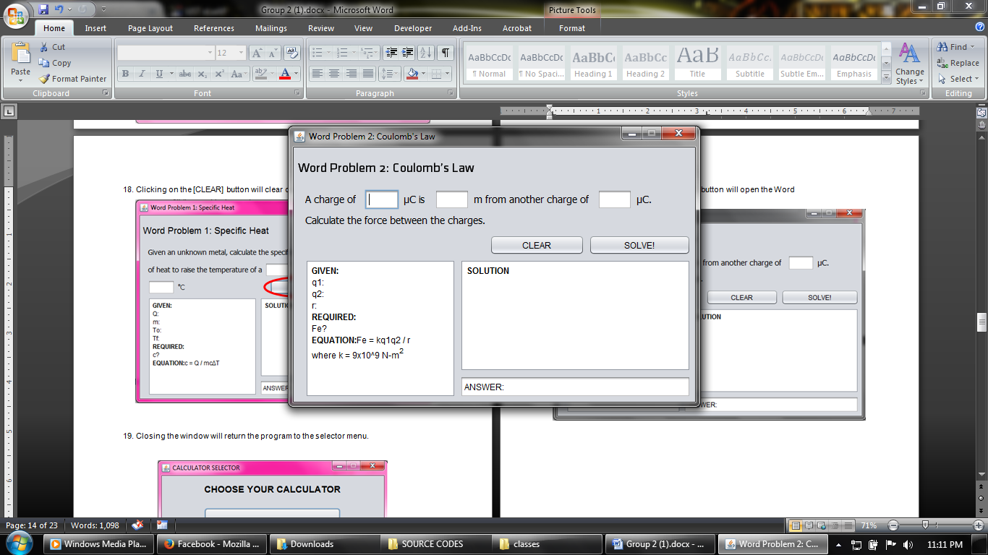

It will show a word problem under Coulomb's Law, the same in format as the word problem 1.

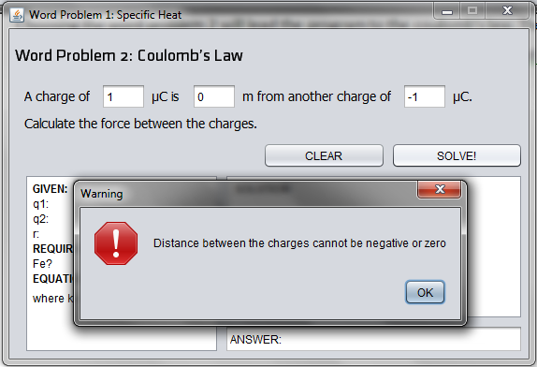21. In any case, that the user inputs a 0 or negative value of the distance field, a warning window will appear informing the user that the distance between the charges cannot be negative or zero.

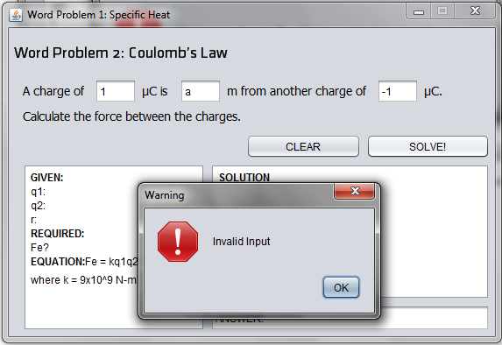22. Special and non-numeric characters, excluding the '-' and the '+', are not allowed.

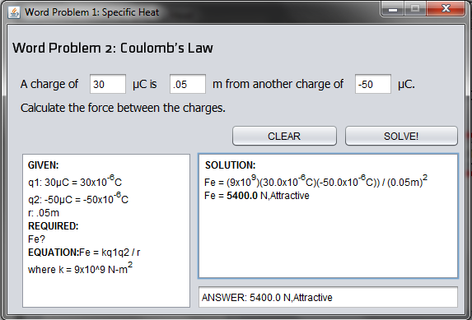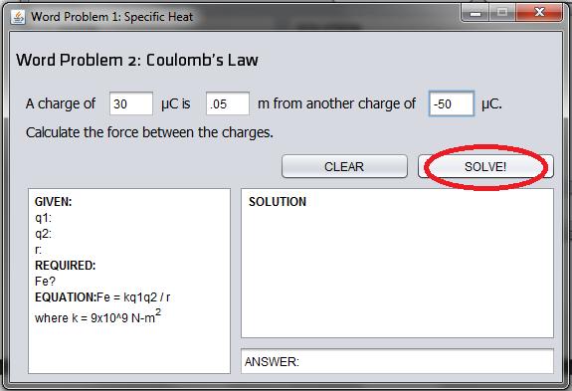23. When proper values are already inserted in the blank fields, the user may now click the [SOLVE!] button for the program to compute for the respective Fe required.   
  
24. The complete solution will be shown in the solution area, and the answer together with the corresponding type of attraction will be shown.

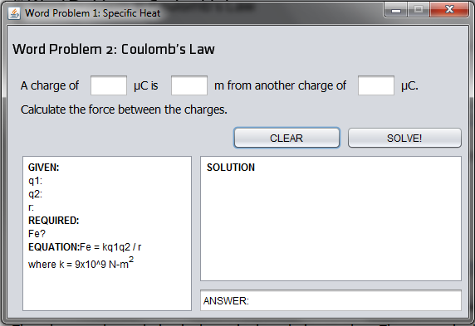25. Clicking on the [CLEAR] button will clear all inputted values and the solution to the word problem.

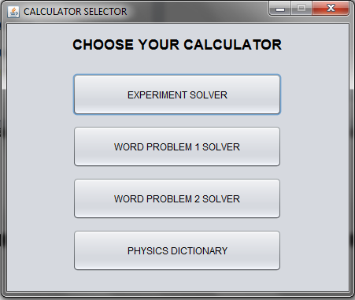  
26. Closing the window will then take the user back to the selector menu

27. Clicking on the [PHYSICS DICTIONARY] button will open the definition of terms and references window which shows terms related to the topics included in the program.

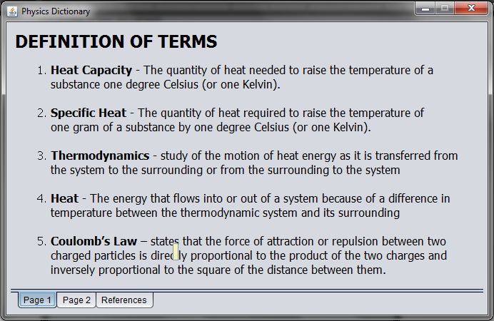

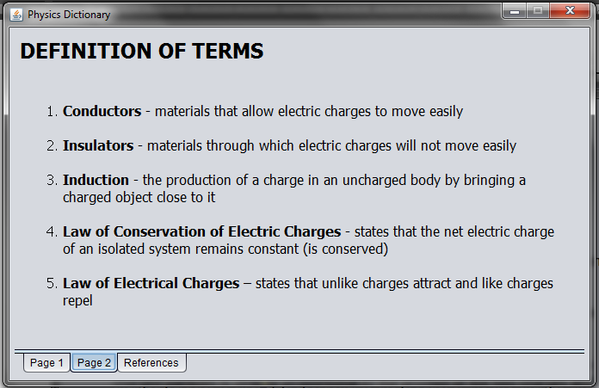28. [Page 2] shows 5 additional definitions.

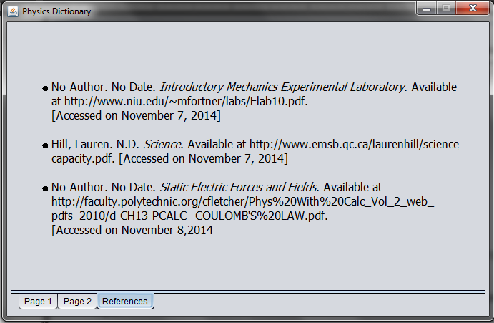29. And the [References] will show the references from which the definitions are taken.

30. Closing the window will return the user to the selector menu where the user may select any of the previous solver in the program or to exit the program completely.

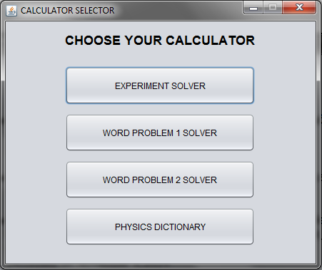

31. Closing the CALCULATOR SELECTOR MENU will show a pop-up of the names of the developers of the program.

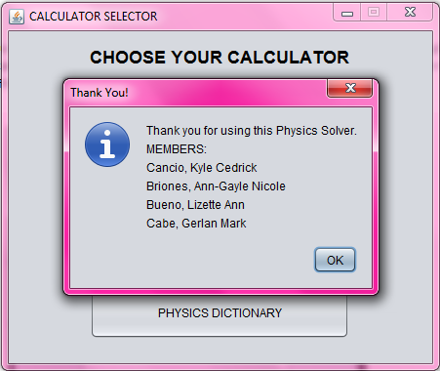

Thank you for using our program! We hope you enjoyed solving with us.